Requirement Analysis Document

Student Lecture Registration System

|  |  |  |  |
| --- | --- | --- | --- |
|  | **NAME** | **SURNAME** | **NUMBER** |
| **1.** | Kaan | CAMCI | 150119063 |
| **2.** | Kadir Berk | YAĞAR | 150120016 |
| **3.** | Sena | VATANSEVER | 150119755 |
| **4.** | Fatih | ÖZTÜRK | 150119519 |
| **5.** | Samet | CAN | 150120528 |
| **6.** | Serdar | ALSAN | 150120034 |
| **~~7.~~** | ~~Erman~~ | ~~KUNDAKÇIOĞLU~~ | ~~150122603~~ |

~~Deleted parts~~

Added parts

1. **Vision**

The goal is to create the simulation that our department uses for student lecture registration. It will be created in accordance with the department's policies and guidelines for attending lectures. Our system's simulation will require an input file as well as arguments like students, lectures, and simulation runs.

1. **Description**

All universities, including our university, require this system for student registration. Without this registration system design, it would be far more difficult for students to participate in the lecture-taking process. On the other hand, students may have a variety of issues when attending lectures, including lecture quota, necessary courses, and collision.

We created this software that simulates course registration in order to avoid these issues. In essence, students register for classes via their curriculum's registration system, while advisors keep track of their requests by taking care of the aforementioned issues.

1. **Requirements**

**Functional Requirements**

1. Lecture requirements

* Lecture must have lecture ID.
* Lecture must have name.
* Lecture must have lecture type.
* Lecture must have credit score.
* Lecture must have quota limit.
* Lecture may have different sessions.
* Lecture may have pre- requisite lecture(s).

1. Student requirements

* Student must have advisor.
* Student must have student ID.
* Student must have transcript.
* Student must have entry date.
* Student must have application registration.
* Student may lecture list. g-student may have debt.

1. Lecture enrollment requirements

* Selected lectures must not have confliction.
* Student must pay education debt.
* Advisor must approve if requirements met.

**Non-Functional Requirements**

* Student information is taken from JSON file as an input.
* Registration system program has to be implemented with JAVA.
* Every step of program should be performed on Command Line Interface.

1. **Use Cases**

**Use Case Name:** Enrolling To lectures**Summary:** In order to get lectures, students must enroll to lectures from system and send request to their advisor.

**Subject:** Student**Basic Flow:**

1. Student opens "Enroll to lectures" tab at site to view lectures.
2. Student needs to select their lectures from a lecture list according to their current curriculum, current semester and their current status of lecture progression.
3. System saves lectures as draft at another tab.
4. Student sends their lecture draft list to their advisor for approval.
5. Student's enrolling to a lecture process has done, lectures from list added to their syllabus.

**Alternative Flow:**

* Step 2: if selected lecture has reached their quota capacity system gives warning to student, then use case returns to step 2.
* Step 4: if student needs to pay education debt and he/she didn't paid it yet, system sends warning to student when he/she sends draft to advisor and student returns to step 2.
* Step 4: if there is conflict at lecture draft student can't send lecture draft to advisor, student returns to step 2.
* Step 5: if student sent TE lecture to advisor for approval, even though they have taken 2 TE lectures in fall semester, advisor rejects that TE lecture.
* Step 5: if student sent TE lecture to advisor for approval, even though they have taken 3 TE lectures in spring semester, advisor rejects that TE lecture. Step 5: if student sent FTE lecture to advisor for approval and if student's graduation is impossible at that semester advisor rejects that FTE lecture.

**Use Case Name:** Approving/Rejecting lecture Requests**Summary:** In order to enregister students to lectures, advisor must enter the system and approve or reject coming requests from their students.**Subject:** Advisor**Basic Flow:**

1. Advisor enters to systems' site and selects coming requests tab from site for approving or rejecting coming requests.
2. Advisor checks coming lecture requests from student.
3. Based on advisor's feedback system sends notification to student.**Alternative Flow:**

* Step 2: if request has TE lecture even though student took 2 TE lectures in fall semester, advisor needs to reject that TE lecture, after that advisor returns to step 2 for another student.
* Step 2: if request has TE lecture even though student took 3 TE lectures in spring semester, advisor needs to reject that TE lecture, after that advisor returns to step 2 for another student.
* Step 2: if request has FTE lecture and if student's graduation is impossible at that semester advisor needs to reject that FTE lecture, after that advisor returns to step 2 for another student. .

1. **Domain Model**

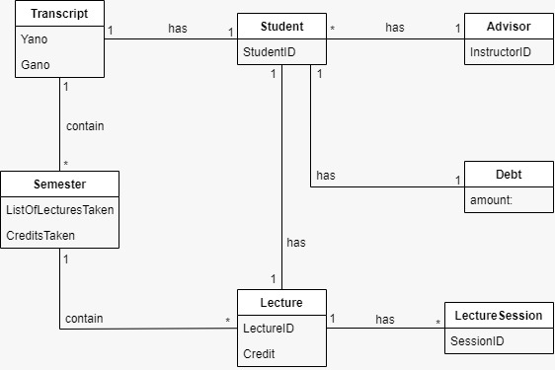

~~Deleted diagram 1~~

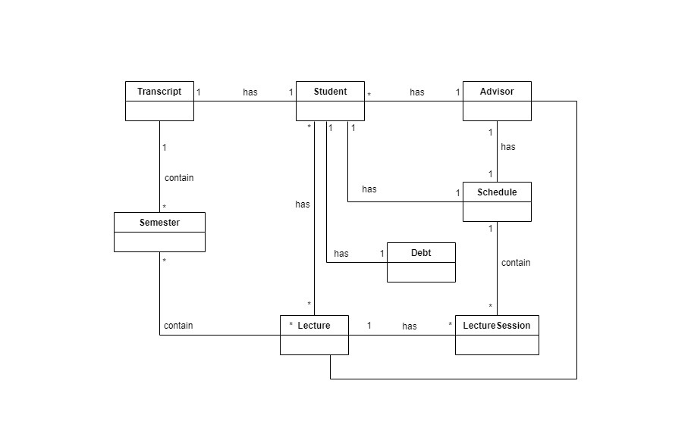

New diagram 1

1. **System Sequence Diagram (SSD)**
2. After viewing the lectures they want to attend, students save their chosen lectures as drafts.
3. Students that owe money for tuition repay it. (This is a alternative action.)
4. The student submits the chosen lectures for approval from the advisor if there are no conflicts.
5. The advisor reviews the lectures the student has selected.
6. The chosen lectures have the advisor's approval.

~~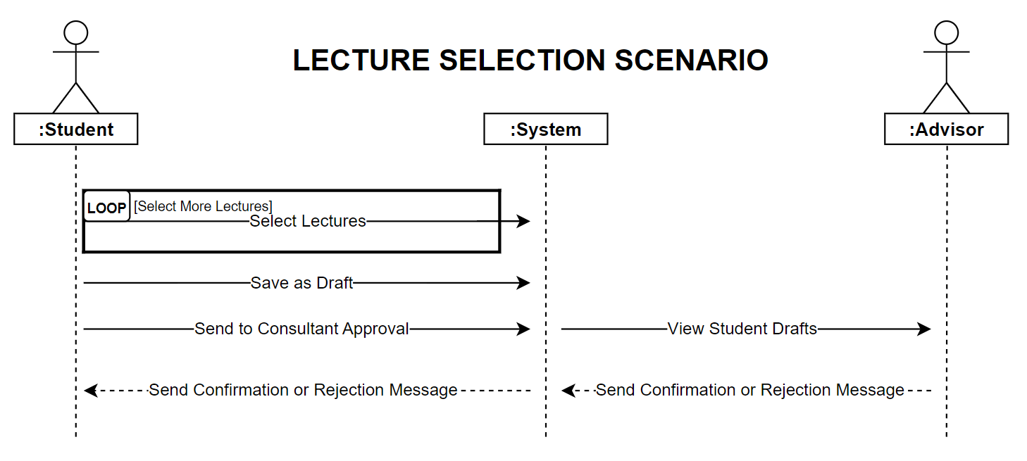~~

~~Deleted diagram 2~~

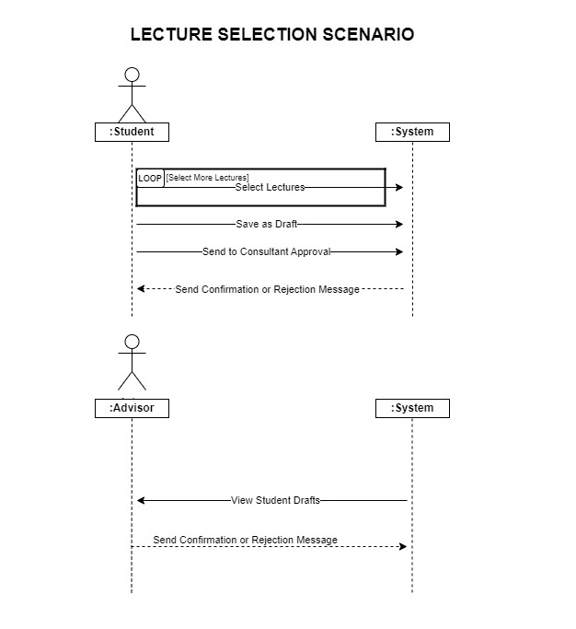

New diagram 2

1. **Glossary**

* **Lecture :** Lessons students take
* **Lecture Session :** given lectures by different lecturers
* **Transcript :** Students’ grade of lecture records
* **Advisor:** Actor who approves or rejects requests of students for taking lectures , stakeholder Curriculum : All of the semester’s lectures
* **Student :** Actor who takes lecture from system , stakeholder
* **Schedule :** Student’s weekly plan
* **Semester :** A half-year term in school, university
* **FTE Lecture :** Faculty Technical Elective Lecture
* **NTE Lecture :** Non Technical Elective Lecture
* **TE Lecture :** Technical Elective Lecture
* **Prerequisite Lecture :** Required lecture must be completed prior to take other Lecture
* **UE Lecture :** University Elective Lecture Credits : Is a way of measuring and impression of particular lecture
* **~~Java :~~** ~~Object Oriented Programming Language~~
* **~~JSON :~~** ~~Standard data interchange and file format~~